**ASSIGNMENT#02**

(Note: After research from internet, wrote in own words nothing has been copied except the image I found on google for explanation)

**Q1.**

ISO 9241:

ISO 9241 is an international standard of ergonomics for formal work that uses visual display terminals. Its components are effectiveness, efficiency and satisfaction. Effectiveness describes the interaction from process point of view and efficiency is related to results while satisfaction is how a user feels. ISO 9241 requirements gives requirements and recommendations that is concerned with hardware, software and environment which is concerned with usability and ergonomics principles. Standard ISO 9241 defines usability in the following way: software is usable when it allows the user to execute his task effectively, efficiently and with satisfaction in the specified context of use.

If we talk about ISO 9241 standard, there are 3 attributes:

1. Effectiveness: Which defines how well do the users achieve their goals using the system?
2. Efficiency: What resources are consumed in order to achieve their goals?
3. Satisfaction: How do the users feel about their use of the system?

* Learnability: How easy is it to learn the system. Also, it is an additional characteristic of usability of ISO 9241 standard. Part of enhanced usability model.
* Security: How secure is the system? Part of enhanced usability model.

This standard presents usability guidelines and is used for evaluating usability according to the use of the software. ISO 9241 recommends a process-oriented approach for usability, by which the usable interactive system is achieved through a human-centered design process. Usable products can be designed by incorporating characteristics and attributes in particular contexts of use. This process alone is not sufficient to ensure efficiency, effectiveness and satisfaction when using the product. To verify whether or not the required level of usability is achieved, it is necessary to measure the performance and the satisfaction of users working with the product. The measurement of usability is a complex interaction between users and context of use; this might produce different levels of usability performance for the same product when it is used in different contexts.

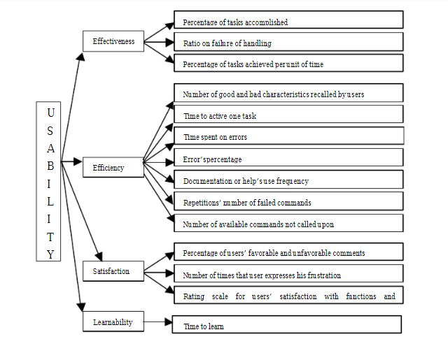

**Q2.**

Schneiderman’s 8 Golden Rules:

1. Strive for consistency
2. Enable Frequent user to use shortcuts
3. Offer informative feedback
4. Design dialogs to yield closure
5. Offer error prevention and simple error
6. Permit easy reversal of actions
7. Support internal locus of control
8. Reduce short team memory load

**Social Application: Snapchat**

1. Strive for consistency

Reason: The UI would never crash when you open camera and view stories one after another or even load filters. The switching between camera and story is quick and smooth.

1. Enable Frequent user to use shortcuts

Reason: Small pic icons show for chat, camera and friends at the liquid bar so they can be used on picture tip as soon as application opens. Swipe up for map is also available as shortcut to open map.

1. Offer informative feedback

Reason: Offers feedback when user uploads a story or wants to delete a snap. The message is shown in a pop up from the bottom of the screen with options also shows time when person uploaded a story.

1. Design dialogs to yield closure

Reason: Dialogue box comes up when user needs to see friends’ info and add friend.

1. Offer error prevention and simple error

Reason: If someone has blocked you, you cannot send them messages and error would come up that your message was not sent or someone cannot be added.

1. Permit easy reversal of actions

Reason: Somebody can be blocked then unblocked from snapchat. Messages can be saved and unsaved as well. Promoting reversal of action

1. Support internal locus of control

Reason: Snapchat would logout the account if the app notices that the user is not genuine or some mysterious activity is noticed.

1. Reduce short team memory load

Reason: Snap chat allows 5 options and middle one is camera and the biggest icon that is easy to remember and use. The 2 options which are used consistently are on very left and right of the camera icon.